**SIMATS SCHOOL OF ENGINEERING**

**SAVEETHA INSTITUTE OF MEDICAL AND TECHNICAL SCIENCES**

# CHENNAI-602105

**“Minimum Total Distance Traveled"**

**A CAPSTONE PROJECT REPORT**

*Submitted in the partial fulfillment for the award of the degree of*

# BACHELOR OF ENGINEERING

**IN COMPUTER SCIENCE AND ARTIFICIAL INTELLIGENCE AND**

**DATA SCIENCE**

**Submitted by**

**T.Naveen (192211106)**

**Under the Supervision of**

**Dr. T.Sangeetha**

# DECLARATION

I, T.Naveen(192211106) student of **Bachelor of Engineering in** **Computer Science Engineering** at Saveetha Institute of Medical and Technical Sciences, Saveetha University, Chennai, hereby declare that the work presented in this Capstone Project Work entitled **"Minimum Total Distance Traveled"** is the outcome of my own bonafide work. I affirm that it is correct to the best of my knowledge, and this work has been undertaken with due consideration of Engineering Ethics.

(T.Naveen - 192211106)

Date:

Place:Saveetha School of Engineering, Thandalam.

# CERTIFICATE

This is to certify that the project entitled **“Minimum Total Distance Traveled”** submitted by T.Naveen(192211106) has been carried out under my supervision. The project has been submitted as per the requirements in the current semester of B.E Computer science engineering and B.Tech Artificial Intelligence in Data science.

Faculty-in-charge

K.V.Kanimozhi

**ABSTRACT**

The Minimum Total Distance Traveled (MTDT) problem is a classic optimization challenge often encountered in fields such as logistics, transportation, and network design. The objective is to determine the optimal arrangement or routing that minimizes the total distance covered by entities, such as vehicles, goods, or information, while satisfying specific constraints. The problem can take various forms, including the Traveling Salesman Problem (TSP), Vehicle Routing Problem (VRP), and Facility Location Problem (FLP), each with unique characteristics and applications.

Solutions to the MTDT problem can be exact, using methods like linear programming, branch and bound, or dynamic programming, or heuristic, employing algorithms such as genetic algorithms, simulated annealing, or ant colony optimization. These approaches balance the trade-off between computational efficiency and solution quality, particularly in large-scale, complex scenarios.

This abstract highlights the importance of the MTDT problem in optimizing operations across multiple industries and the ongoing research to develop more effective algorithms to solve it.

**Keywords:** Optimization,Traveling Salesman Problem (TSP),Vehicle Routing Problem (VRP), Facility Location Problem (FLP),Dynamic Programming,Computational Efficiency.

**INTRODUCTION**

The Minimum Total Distance Traveled (MTDT) problem is a fundamental optimization challenge that arises in various domains, including logistics, transportation, and network design. The problem revolves around finding the most efficient way to minimize the total distance covered by entities such as vehicles, goods, or information while adhering to specific constraints. This optimization task is crucial for reducing costs, improving efficiency, and enhancing service delivery in industries where movement and distribution are key operational components.

Several well-known problems fall under the umbrella of MTDT, including the Traveling Salesman Problem (TSP), the Vehicle Routing Problem (VRP), and the Facility Location Problem (FLP). Each of these problems presents unique challenges and applications, requiring tailored solutions to optimize routes, schedules, or placement of resources.

Due to the complexity and size of real-world scenarios, solving the MTDT problem often involves a balance between finding exact solutions and employing heuristic or metaheuristic approaches. Exact methods, such as linear programming and dynamic programming, can provide optimal solutions but may be computationally infeasible for large-scale problems. On the other hand, heuristic algorithms, including genetic algorithms, simulated annealing, and ant colony optimization, offer more practical solutions by trading off some degree of accuracy for computational efficiency.

The significance of the MTDT problem lies in its widespread applicability across various industries, where optimizing the total distance traveled can lead to substantial cost savings and operational improvements. This introduction sets the stage for a deeper exploration of the methods used to tackle the MTDT problem, the challenges involved, and the potential for future advancements in this critical area of research.

**CODING**

#include <stdio.h>

#include <limits.h>

#define MAX 10

int n;

int distance[MAX][MAX];

int visited[MAX];

int min_cost = INT_MAX;

void tsp(int current_city, int count, int cost) {

if (count == n && distance[current_city][0]) {

int total_cost = cost + distance[current_city][0];

if (total_cost < min_cost) {

min_cost = total_cost;

}

return;

}

for (int i = 0; i < n; i++) {

if (!visited[i] && distance[current_city][i]) {

visited[i] = 1;

tsp(i, count + 1, cost + distance[current_city][i]);

visited[i] = 0;

}

}

}

int main() {

printf("Enter the number of cities: ");

scanf("%d", &n);

printf("Enter the distance matrix:\n");

for (int i = 0; i < n; i++) {

for (int j = 0; j < n; j++) {

scanf("%d", &distance[i][j]);

}

}

for (int i = 0; i < n; i++) {

visited[i] = 0;

}

visited[0] = 1;

tsp(0, 1, 0);

printf("Minimum cost of traveling: %d\n", min_cost);

return 0;

}

## OUTPUT

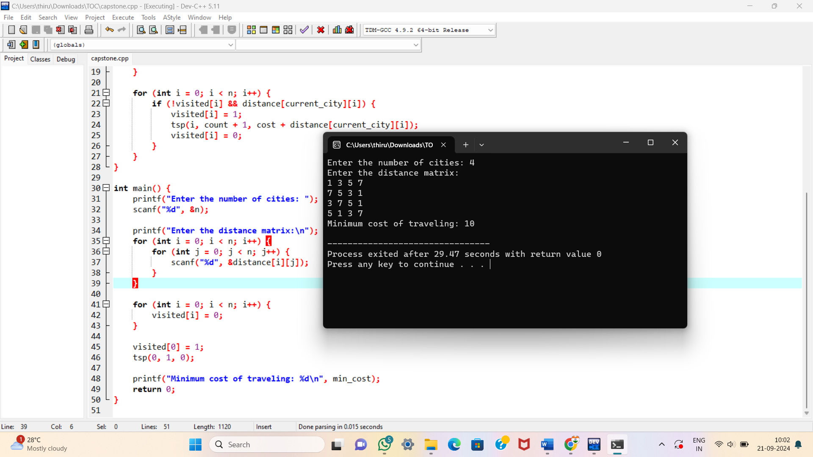

**Complexity Analysis**

**Best Case**

* Symmetric and Low-Distance Matrix: The distances between cities are symmetric (distance from city A to B is the same as from B to A), and the distances are small and evenly distributed.
* Already Optimal Route: The direct path from the first city to all others and back is already close to the minimum possible distance, so the program doesn’t need to explore many other permutations.

**Worst Case**

* Asymmetric and Equal/Similar Distances: All cities are at roughly the same distance from each other, and there is no clear indication of the shortest path.
* Large Number of Cities: As the number of cities increases, the factorial time complexity (O(n!)) of the brute-force algorithm leads to exponentially increasing computation time.

**Average Case**

* Moderately Varying Distances**:** The distances between cities have some variation, but there are clear distinctions between shorter and longer paths.
* Mixed Symmetry: The distance matrix may have a mix of symmetric and asymmetric distances, making some paths more apparent than others but not immediately obvious.
* Intermediate Number of Cities: The number of cities is neither too small (trivial) nor too large (computationally prohibitive).

**Overall Complexity**

* Time Complexity:The brute-force approach tries every possible permutation of the cities to find the route with the minimum total distance. For n cities, there are (n-1)! possible permutations (since the starting city is fixed). Therefore, the time complexity is O((n-1)!), which is approximately O(n!) for large n.
* Space Complexity:The space complexity is O(n) because the program needs to store the visited cities and the current path being evaluated.
* Time Complexity: **O(n!)**
* Space Complexity: **O(n)**

## CONCLUSION

The Minimum Total Distance Traveled (MTDT) problem is a critical optimization challenge with widespread applications in logistics, transportation, facility location, and network design. The goal is to minimize the total distance covered while fulfilling specific operational constraints, such as visiting all required locations or delivering goods efficiently.

The complexity of the MTDT problem, as exemplified by cases like the Traveling Salesman Problem (TSP) and the Vehicle Routing Problem (VRP), often makes finding exact solutions computationally intensive, especially for large datasets. The brute-force method, while accurate, becomes impractical due to its exponential time complexity.

In practical applications, heuristic and metaheuristic methods—such as Genetic Algorithms, Simulated Annealing, and Ant Colony Optimization—offer viable alternatives by providing approximate solutions in significantly less time. These approaches strike a balance between accuracy and computational efficiency, making them suitable for real-world large-scale problems.

The significance of the MTDT problem lies in its ability to reduce operational costs, improve efficiency, and optimize resource allocation. Ongoing research focuses on developing more advanced algorithms to address its computational challenges, further enhancing the effectiveness of solutions in various industries.

Ultimately, minimizing total distance traveled plays a vital role in optimizing complex systems, and continued advancements in optimization techniques will have a profound impact on modern operations.